Name: ____________________________________ Date: _______________

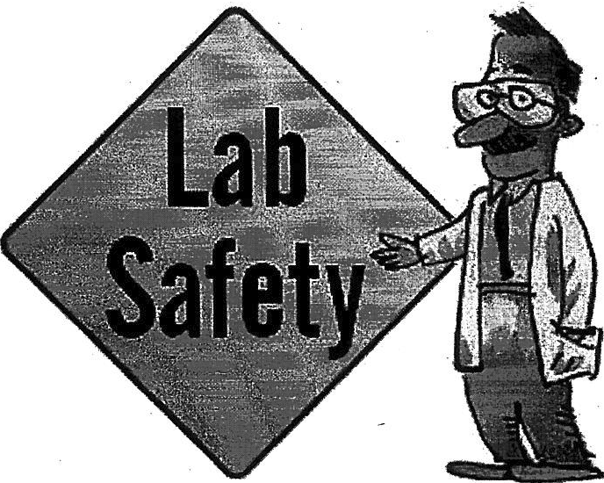
LAB SAFETY
Read each statement. Place a ''T" for true or "F" for false on the line before each statement.
_ 1 .The laboratory is a good place for practical jokes.
___ 2. When using a scissor or knife, you must always cut away from yourself.

_ 3. It is unnecessary to report minor laboratory accidents.

___ 4. Chemicals should never be tasted.

_ 5.Only the teacher needs to know the location of all the safety devices.

_ 6. Students must be aware of all procedures and safety rules before doing an investigation.

_ 7. Students may eat or drink during certain experiments, but not during others.

___8. When unplugging electrical equipment, it is best to remove the plug by yanking on the cord to avoid any chance of being electrocuted.
9. All glassware, equipment, and your work station area should be cleaned as soon as you have finished your investigation.

10. All sharp and pointed objects should be handled with extreme care.

11. While heating liquids students should always point the test tube toward themselves so they can protect others and can watch exactly what they are doing.

