Assignment: We will continue our unit: Introduction to Chemistry! Here, you will learn more about mixtures and how we can separate them. The next 2 assignments of this chapter can be found in this document. You will be sent reminders through the Remind App to keep you on track.

ASSIGNMENTS ARE DUE BY: Today 3/31 by midnight.

Assignment 4: Watch the Slide Show on Heterogeneous and Homogeneous Mixtures. The link is attached below.

https://www.youtube.com/watch?v=Zq6WuZAmd3k&feature=youtu.be

Assignment 5: Virtual Lab Introduction to Chemistry: Virtual Mixtures, Elements, and Compounds Lab

Assignment: Complete the lab using the website provided. You will need flash player to complete online. If you are unable to use flash player on your device, all of the pictures/data/instructions are attached to the end of this document (will be located after the assignment checklist at the end of this document). You will complete the lab from the tutorial and record all responses on a Google Form. It is best to open two windows or tabs … one for the lab, one for the Google Form so you can use both at once. The instructions are on the lab website itself.

LAB:
https://my.hrw.com/sh2/sh07_10/student/flash/virtual_investigations/hst/mix/hst_mix_vi.html

GOOGLE FORM TO RECORD RESPONSES:
https://forms.gle/9MhW88e3akZQXD9AA

Assignment Checklist:

To verify you are done, you should have done the following:

- Watched the Slide Show on Heterogeneous and Homogeneous Mixtures
- Separating a Mixture Google Form

These assignments will be posted on the Portal. If there is a checkmark or “Co” symbol, that means they have been submitted and collected. If you see --, an “Mi,” or it is blank, that means they were not submitted.

Below is the information for assignment #2 if flash doesn’t work on your device.
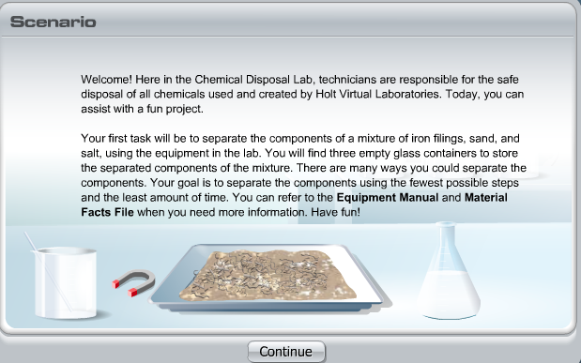

Read through (or listen to) the scenario and click continue.

- Click on the lab coat, protective gloves, and safety goggles. Then, click Enter.
- Think about the most logical order in which to separate the components. Then, click the container with the label of the component you wish to separate first.
- To change your selection, click another container. For example, you may decide to separate iron filings instead of sand. To do so, click the container labeled “iron filings.”
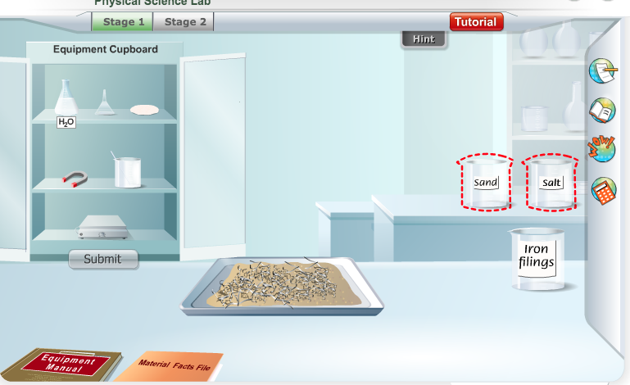

- Use the Materials Facts File at any time to learn more about the component you are trying to separate.
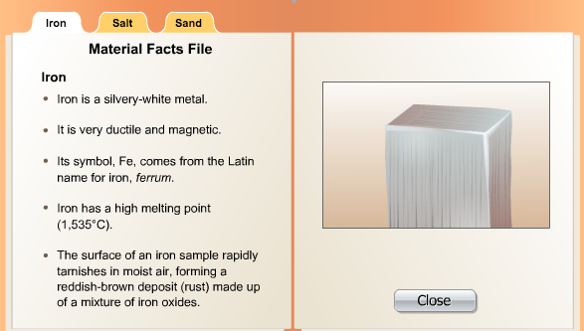
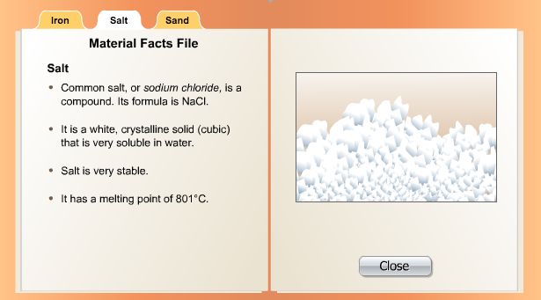
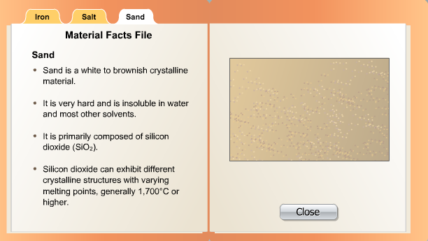

- Click on the Equipment Manual on the lower left side of the screen to read about the equipment you can use to separate the components of the mixture.
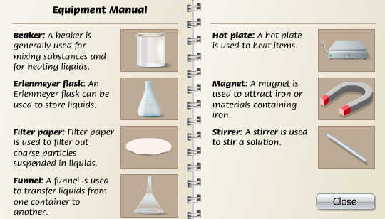

- Click the Equipment Cupboard to open it.
- Click all of the equipment you will need to separate the component. Remember: your goal is to separate the components using the fewest possible steps and the least amount of time!
- Click on Separate to begin the process of separation.
- Click submit to collect the component in the glass container
- Repeat steps 2-9 for the remaining 2 components.

ANSWER ALL QUESTIONS FOR STAGE 1 ON THE GOOGLE FORM

MOVE ON TO STAGE 2

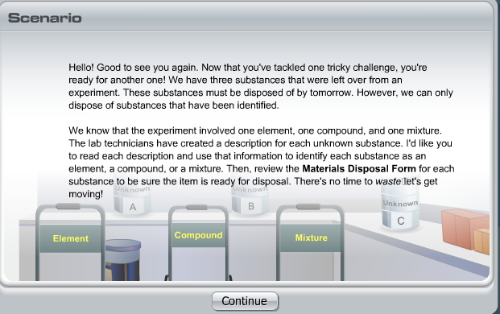
- Click on the lab coat, protective gloves, and safety goggles. Then, click Enter.
- Move the points over a container to view the description of the unknown substance within. Screenshots of each description are below.

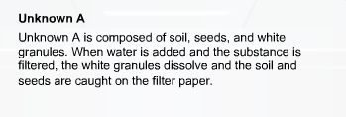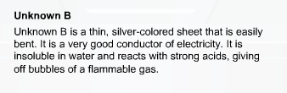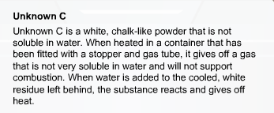
- Identify the unknown substance as an element, compound, or mixture by placing it on the appropriate cart. Then, click evaluate.
- Repeat steps 2-3 for the other two unknown substances.
- Click the Materials Disposal Form to review your results. Click close when you are finished.

ANSWER ALL QUESTIONS FOR STAGE 2 ON THE GOOGLE FORM

